TYPE 3N
Model No: LE129-1(W/W),
LE129-2 (W/OR)
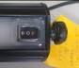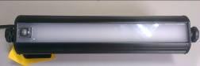
Power switch
Features
- 72pcs LED of LE129-1( Full brightness model / Energy saving model)
- 36pcs LED of white light and 36pcs LED of orange red light ( white/Orange Red version)
- LE129-2 ( white/ orange red) is for mosquito repellent
- Two sections operation
- Low power consumption and long life time
- 12V DC input voltage
- Design of power switch on the exterior
- Protection against lightning
- Water proof
- IP67

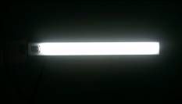
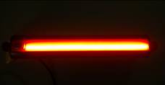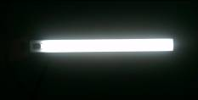
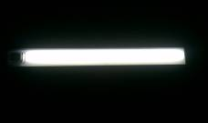

White/ Orange Red version <Up> energy saving model
<Down> Brightness model

Applications
- Ideal for interior lighting of the Truck bodies, campers and storage compartments.
- Equipped with mounting brackets for easy installation.
- Mosquito repellent of white/ Orange red version
- Water proof

Product Structure
Main Components | Materials | Color
Lens | PC | Mat White
Housing | Aluminum | Black
LED | 72 pcs LED | White (full brightness)
LED | 36pcs/36pcs LED | White/orange red

Drawing Dimension (Dimension: 355(L) x59(W) x67(H), Unit: mm)

Maximal Operation Values
Description | Symbol | Value |  | Unit
Description | Symbol | LE129-1(W/W) | LE129-2(W/OR) | Unit
Voltage Input | V_{IN} | 12 | 12 | V DC
Current Input | I_{IN} | 350~640 mA | 305~295 mA
Power Dissipation | P_{D} | 4/ 8 | 4 | W
Environmental Temperature | T_{ope} | -30 ~ +40 |  | ℃
Storage Temperature | T_{sto} | -40 ~ +80 |  | ℃

Illumination
Description | Symbol | Typical | Unit
Luminous flux (White/white)  <LE129-1> | F | 240(single) | lm
Luminous flux (White/white)  <LE129-1> | F | 450 (dual) | lm
Luminous flux (White/orange)  <LE129-2> | F | 210 (white) | lm
Luminous flux (White/orange)  <LE129-2> | F | 15 (orange red) | lm

Installation
Top View | Side View

Mosquito Repellent Lighting Information:

(From light bulb technology blog)
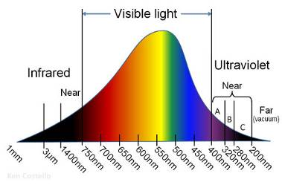
“The human eye can only perceive a small band of wavelengths in the light spectrum, from about 390 to 750 nm. Insects perceive a similarly small band of the light spectrum, though their band of vision is shifted further to the “right” of the spectrum than ours. In fact, any wavelength higher than about 650 nm is virtually invisible to most flying insects.“

